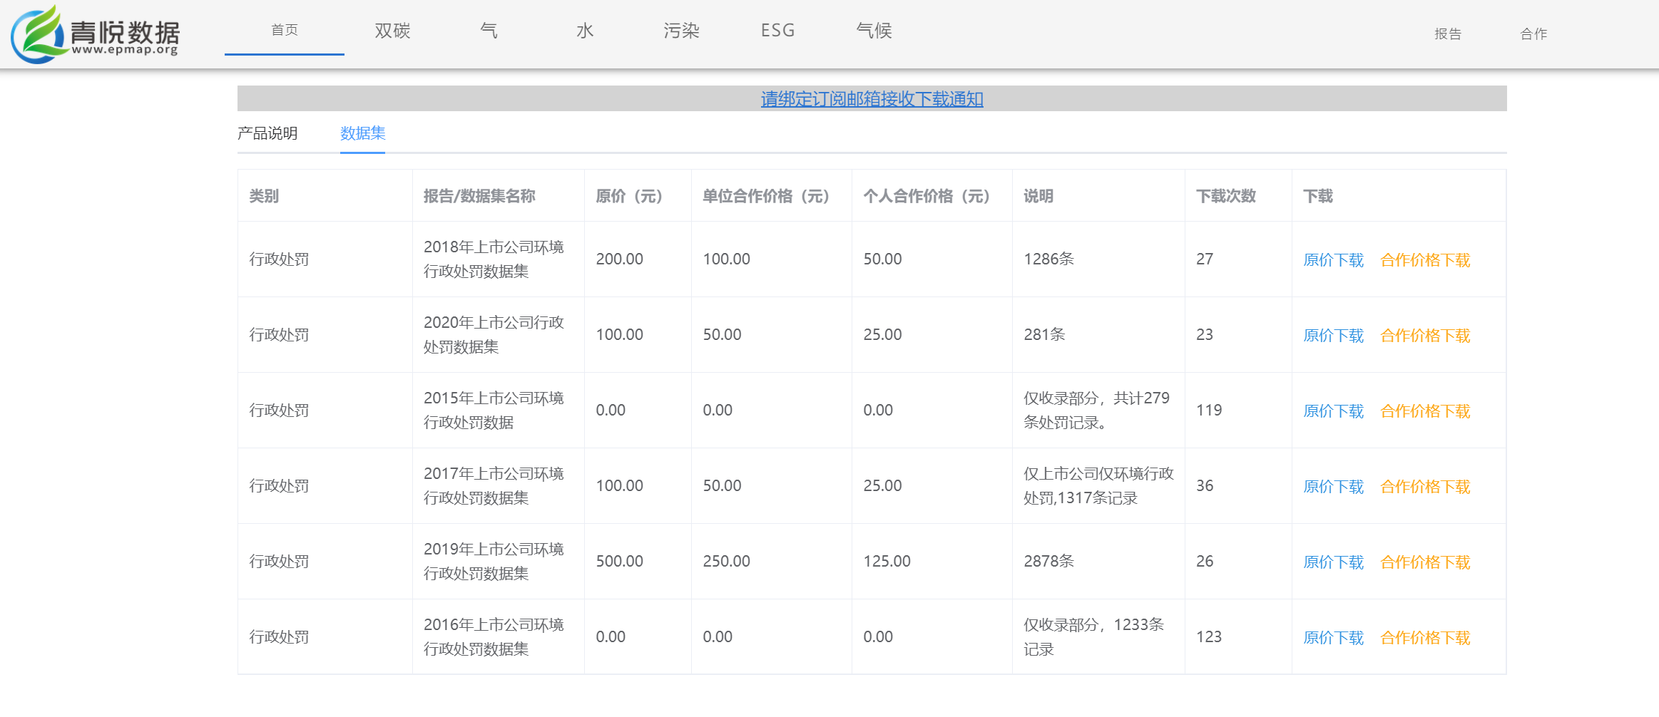
https://data.epmap.org/product/punishment

